Inntopia
Brand Guidelines

Updated December 8, 2022

Intro

From a branding perspective, we have a few goals as a company:

- We want people to know what we do
- We want people to remember us
- We want people to think happy thoughts when they see our name

Brand guidelines are the glue that helps holds all these pieces together. It helps that everything from that awesome blog post to our handouts at tradeshows to all tie together and tell the same story in the same way to increase our changes of all of the above.

So, I’ve put together this little guide to help you stay, as we say in the biz, “on brand.”

Enjoy.

Colors

Let’s start with some colors. Naturally, our main color is orange. Orange is great for subheaders, icons, etc. while the light orange is best for backgrounds:

- Dark Orange – HEX: #EC8435, RGB: 236, 132, 53
- Light Orange – HEX: #FFF1DB, RGB: 255, 241, 219

Text
For text we keep it simple with an almost black:

- Dark Gray – HEX: #222222, RGB: 34,34,34

Other Colors
Finally, we have four complementary colors. We sometimes use these to illustrate the verticals we sell to, but they can be used for accents and variety when needed.

- Green (golf) – HEX: #61a273, RGB: 97,162,115
- Blue (ski) – HEX: #42858f, RGB: 66,133,143
- Yellow (attractions) – HEX: #f1b822, RGB: 241,184,34
- Purple (hospitality) – HEX: #9c6168, RGB: 156,97,104

Fonts

We use two fonts. One for headers, one for body text.

Headers  For headers we use Futura PT Bold. Sticking with the default sizes recommended by word is a great way to go for various levels, which we’ve done in this done.  Heading 1  Heading 2  Heading 3 | Body  For body text we use Chaparral Pro. Depending on how much content you have, sizes 10-14 are a good range to stick within. Larger will feel easier to read and more approachable, smaller a bit more official and formal.  Size 14 Text  Size 12 Text  Size 10 Text

Logo

And, guess what, we have a logo! A good rule of thumb for sizing a logo in a file or project is to never let the logo be more than 1/3 the height or width of the space it’s filling. You can go even narrower than that when the logo isn’t the main message (like on a letterhead).

Examples
So if you wanted to center align a logo in this doc, you’d do something like this (our text is 6.5” wide, so we this logo is just over 2” wide):



This, on the other hand would NOT be a great look:



Sometimes, we’ll need to put this logo on other colors (like the navigation bars of our apps). In these situations, just go with our solid white version.



Titles

We often use a two-tone header. In this case we’ll just do an orange pre-header that is slightly smaller than the almost black header. Whatever size you go with, making the pre-header just smaller than the header works great.

Preheader
Awesome Title Goes Here

Preheader
Awesome Title Goes Here

Preheader
Awesome Title Goes Here

Mark

Sometimes we use a small mark when a full logo is either too much or redundant. In this case, we put a white orange compass on our orange background. This can either be square or rounded.



A good example of where this makes sense is on social media where our name is already spelled out right next to where the logo is shown, so we just use this mark.

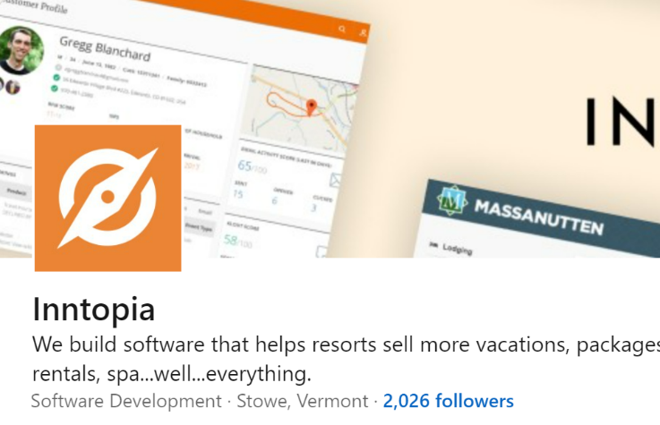

Questions?

If you’ve read one of these in the past, you might notice that these Brand Guidelines are a little bit less particular in years past. That’s intentional. Just do your best, don’t sweat things too much, and just holler if you have any questions.

